|  |  |  |  |
| --- | --- | --- | --- |
| **Name of Student: NINAD AVINASH PATIL** | | | |
| **Roll No: 33** | | **Lab Practical Number: 3(C)1** | |
| **Title of Lab Practical: LINQ**  **i. Use object**  **Design a web page to display the employee information from table to grid control. Use LINQ to Objects.** | | | |
| **DOP: 06/04/2021** | | **DOS: 10/04/2021** | |
| **CO Mapped: CO1** | **PO Mapped: PO3, PO5, PO7,**  **PO12, PSO1, PSO2** | **Faculty Signature:** | **Marks:** |

**Practical No 3(C)1**

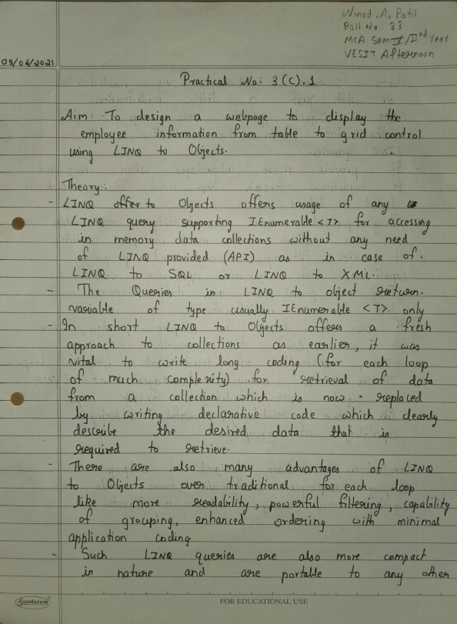



**Code:**

**WebForm1.aspx.cs**

using System;

using System.Collections.Generic;

using System.Linq;

using System.Web;

using System.Web.UI;

using System.Web.UI.WebControls;

using System.Collections;

namespace P3C

{

public partial class WebForm1 : System.Web.UI.Page

{

protected void Page_Load(object sender, EventArgs e)

{

var data = getdata();

var query = from Employee employee in data

where employee.Name == "Ninad"

select employee;

GridView1.DataSource = query;

GridView1.DataBind();

}

public ArrayList getdata()

{

ArrayList arrList = new ArrayList();

arrList.Add(

new Employee

{

Name = "Ninad",

Department = "IT",

ID = "20133",

Salary = "50000"

});

arrList.Add(

new Employee

{

Name = "Arindam",

Department = "HR",

ID = "20131",

Salary = "30000"

});

arrList.Add(

new Employee

{

Name = "Sarath",

Department = "Sales",

ID = "20132",

Salary = "20000"

});

arrList.Add(

new Employee

{

Name = "Amit",

Department = "Marketing",

ID = "20134",

Salary = "250000"

});

return arrList;

}

public class Employee {

public string Name { get; set; }

public string Department { get; set; }

public string ID { get; set; }

public string Salary { get; set; }

}

protected void GridView1_SelectedIndexChanged(object sender, EventArgs e)

{

}

}

}

**WebForm1.aspx**

<%@ Page Language="C#" AutoEventWireup="true" CodeBehind="WebForm1.aspx.cs" Inherits="P3C.WebForm1" %>

<!DOCTYPE html PUBLIC "-//W3C//DTD XHTML 1.0 Transitional//EN" "http://www.w3.org/TR/xhtml1/DTD/xhtml1-transitional.dtd">

<html xmlns="http://www.w3.org/1999/xhtml">

<head runat="server">

<title></title>

</head>

<body>

<form id="form1" runat="server">

<div>

LINQ to Objects</div>

<asp:GridView ID="GridView1" runat="server"

onselectedindexchanged="GridView1_SelectedIndexChanged">

</asp:GridView>

</form>

</body>

</html>

**Output:**

